PROJECT REPORT
ON
Understanding Customer Preferences and Restaurant Trends using Data Analytics using Python
AS
A PARTIAL REQUIREMENT FOR THE DEGREE
OF
BACHELOR OF COMPUTER APPLICATION (BCA)


FOR SUBJECT
602 DATA ANALYTICS USING PYTHON

Submitted by:
Student name (exam seat no.)
Student name (exam seat no.)

Guided by:
Asst. Prof. Hitesh P Patel
Sutex Bank College of Computer Applications and Science, Amroli

PROJECT Completion Certificate

Acknowledgement

INDEX

Sr. No. | Chapter title | Page no.
1 | Project definition
2 | Dataset details
3 | Python tools and libraries used
4 | Understanding the data
5 | Understanding spread of data
6 | Automating EDA using python
7 | Handling missing data and outliers
8 | Univariate analysis
9 | Bivariate analysis
10 | Multivariate analysis
11 | Regression analysis (supervised learning)
12 | Model evaluation
13 | Classification model
14 | Overfitting and underfitting
15 | Conclusion
16 | References

CHAPTER 1: PROJECT DEFINITION
1.1 Introduction
The food and restaurant industry generates a huge amount of data through customer reviews, ratings, online orders, and pricing information. Analysing this data helps businesses understand customer preferences, improve service quality, and make data-driven decisions.
In this project, we perform data analytics on a real-world Zomato restaurant dataset using Python. The project focuses on Exploratory Data Analysis (EDA), data cleaning, data visualization, and basic supervised learning techniques such as regression and classification.

1.2 Problem Statement
To analyse restaurant data and understand:
- Popular restaurant categories
- Customer rating behaviour
- Price preference for dining
- Impact of online ordering on ratings
- Prediction of restaurant ratings using regression
- Classification of restaurants as high-rated or low-rated

1.3 Objectives
The main objectives of this project are:
- To understand and explore a real-world dataset
- To perform univariate, bivariate, and multivariate analysis
- To handle missing data and clean noisy values
- To automate EDA using Python
- To apply regression and classification models
- To evaluate models using error metrics such as MSE, MAE, and R²

CHAPTER 2: DATASET DETAILS
2.1 Dataset Information
- Dataset Name: Zomato Restaurant Dataset
- Dataset Type: Structured CSV Dataset
- Domain: Restaurant / Business Analytics
- Source: Open-source dataset (https://media.geeksforgeeks.org/wp-content/uploads/20250117023324808265/Zomato-data-.csv)

2.2 Dataset Description
The dataset contains the following attributes:
Column Name | Description
Name | Name of the restaurant
online_order | Availability of online ordering (Yes/No)
book_table | Table booking facility
Rate | Customer rating
Votes | Number of customer votes
approx_cost(for two people) | Approximate dining cost
listed_in(type) | Restaurant category

CHAPTER 3: PYTHON TOOLS AND LIBRARIES USED
- Python 3.x – Core programming language
Python is a programming language widely used by Data Scientists. Python has in-built mathematical libraries and functions, making it easier to calculate mathematical problems and to perform data analysis.
- Pandas – Data manipulation and analysis
Pandas is a fundamental, open-source Python library for data manipulation and analysis, providing fast, flexible, and expressive data structures like DataFrames (2D tables) and Series (1D arrays) to handle tabular data efficiently, making it ideal for cleaning, transforming, exploring, and analyzing large datasets in data science, machine learning, and analytics. It simplifies tasks like reading/writing files (CSV, Excel), handling missing data, filtering, grouping, merging, and performing statistical analysis, integrating seamlessly with other tools like NumPy and Matplotlib.
- NumPy – Numerical computation
NumPy (Numerical Python) is a foundational Python library for data science, primarily used for its efficient multi-dimensional array object (the ndarray) and high-performance mathematical functions. It is a core component of the Python data science ecosystem, serving as the backbone for other major libraries like Pandas, Matplotlib, and scikit-learn.
- Matplotlib – Data visualization
Matplotlib is a foundational, powerful Python library for creating a wide range of static, animated, and interactive visualizations in data science. It provides extensive customization options and serves as the backbone for many other visualization libraries like Seaborn.
- Seaborn – Statistical visualization
Seaborn is a powerful Python library for statistical data visualization, built on Matplotlib, that creates attractive, informative plots with minimal code, seamlessly integrating with pandas DataFrames to reveal trends, relationships, and patterns in data, making it essential for Exploratory Data Analysis (EDA). It offers high-level functions for complex plots (like distributions, regressions, heatmaps, violin plots) with beautiful default styles, color palettes, and themes, simplifying the process of understanding data structures and distributions.
- Scikit-learn – Machine learning algorithms
Scikit-learn (sklearn) is the most popular, open-source Python library for classical machine learning, providing simple and efficient tools for predictive data analysis. It is built on top of the scientific Python stack (NumPy, SciPy, Matplotlib) and is an essential tool for data scientists.

CHAPTER 4: UNDERSTANDING THE DATA
4.1 Importing Libraries and Dataset
# Step 1: Importing necessary Python libraries.
import pandas as pd
import numpy as np
import matplotlib.pyplot as plt
import seaborn as sns

# Step 2: Loading Dataset and Creating the data frame.

df = pd.read_csv(r'dataset\zomato-data.csv')
pd.set_option('display.max_columns', None)
print(df.sample(5))

OUTPUT:-

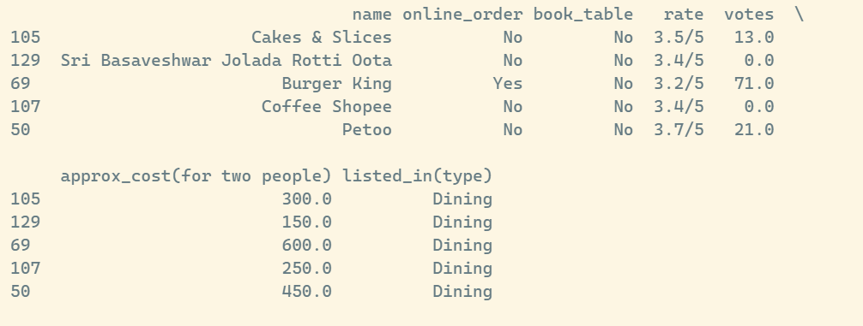

4.2 Dataset Structure
# display shape of data print(dataframe.shape)
df.shape
--OP--
# Getting summary of the dataframe using df.info()
df.info()
--OP--

This helps identify:
- Number of rows and columns
- Data types
- Missing values

CHAPTER 5: UNDERSTANDING SPREAD OF DATA
With our dataset we have used histogram with “kde=True” to understand the distribution and spread of data in column “rate” (user ratings).
5.1 Distribution of Ratings
plt.figure(figsize=(8,5))
sns.histplot(df['rate'], bins=10, kde=True)
plt.title("Distribution of Restaurant Ratings")
plt.show()
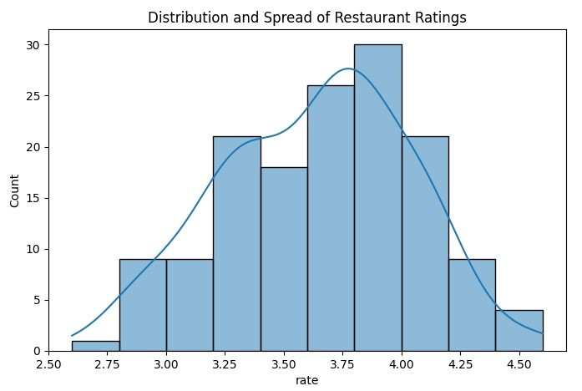

5.2 Cost Distribution by Online Order
boxplot to understand the data spread of “approximate cost for two people” by online order availability.
plt.figure(figsize=(8,5))
sns.boxplot(x='online_order', y='approx_cost(for two people)', data=df)
plt.title("Cost Spread by Online Order")
plt.show()
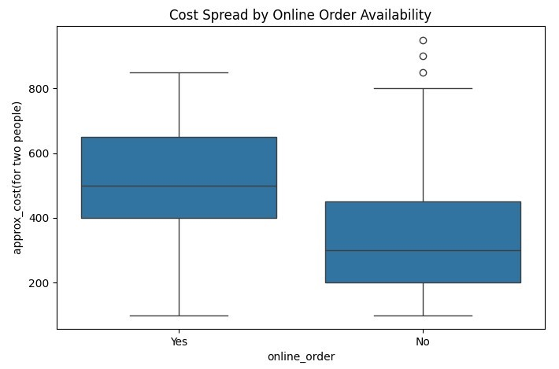

CHAPTER 6: AUTOMATING EDA USING PYTHON
Automating Exploratory Data Analysis (EDA) in Python is achieved using specialized libraries that generate comprehensive, interactive reports with just a few lines of code.
# Create Function to Automate EDA
def auto_eda(data):
print("Dataset Info:")
print(data.info())
print("\nDataset Description:")
print(data.describe())
print("\nMissing Values:")
print(data.isnull().sum())

auto_eda(df)
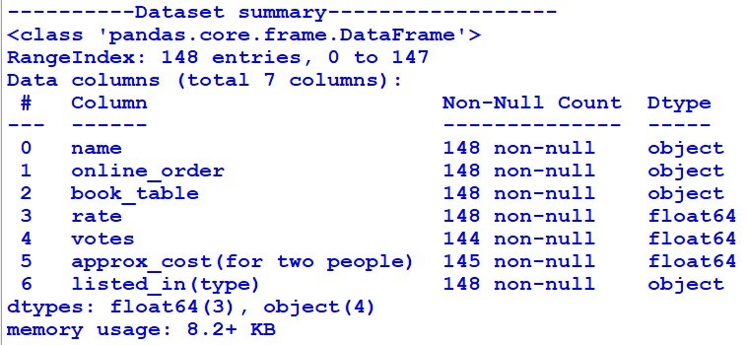

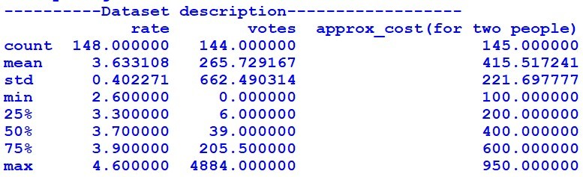

CHAPTER 7: HANDLING MISSING DATA AND OUTLIERS
7.1 Cleaning Rating Column

Data Cleaning
Before moving further we need to clean and process the data. In this dataset the “rate” column contains data in string format having values like “<rating> / 5“. Here “ /5” is unwanted string (noise in data), which needs to be removed. And then the rating has to be transformed into float data type so that the rating data can be used for analysis. Convert the rate column to a float by removing denominator characters.
def handle_rate(value):
value = str(value).split('/')
return float(value[0])

df['rate'] = df['rate'].apply(handle_rate)
print("----------After cleaning rate column, printing top records")
print(dataframe[['name','rate']].head()) .
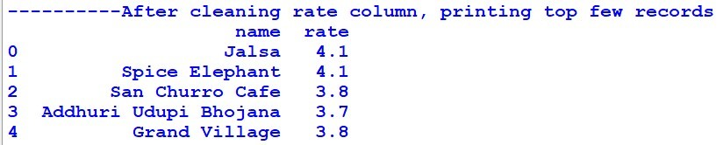

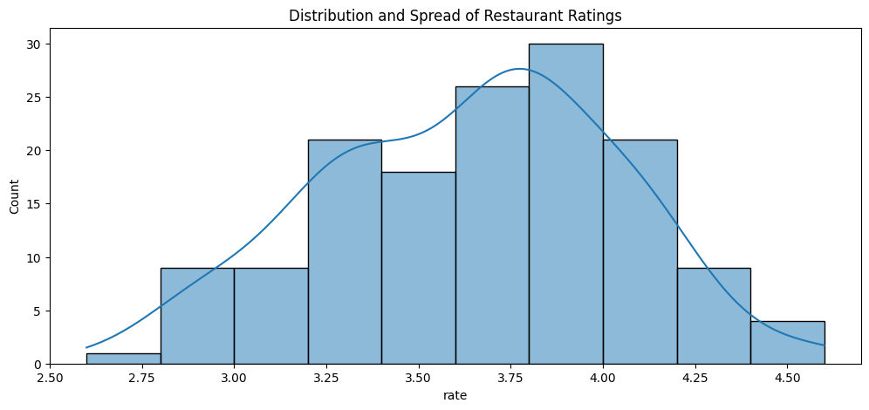
7.2 Handling Missing Values
df.fillna(df.mean(numeric_only=True), inplace=True)
--OP—

7.3 Handling Outliers
Outliers in this dataset are meaningful and hence not removed.

CHAPTER 8: UNIVARIATE ANALYSIS
Here we are exploring restaurant types as a part of univariate analysis under Exploratory Data Analysis. This will answer our question 1: Identify popular restaurant categories.
We are using countplot() for this purpose. '''countplot() using Seaborn is commonly used in EDA to visualize categorical data. A countplot shows the count (frequency) of each unique category in a categorical variable using bars.
Exploring Restaurant Types (EDA - Univariate Analysis)
sns.countplot(x='listed_in(type)', data=df)
plt.title("Restaurant Types")
plt.show()
--OP---
Conclusion: Majority of restaurants belong to the dining category.

Identify the Most Voted Restaurant
max_votes = dataframe['votes'].max()
restaurant_with_max_votes = dataframe.loc[dataframe['votes'] == max_votes, 'name']
print('Restaurant(s) with the maximum votes:')
print(restaurant_with_max_votes)

Conclusion: Empire State restaurant is most voted restaurant
Online Order Availability
sns.countplot(x=dataframe['online_order']) plt.show()

--OP—
Conclusion: majority of the restaurants do not accept online orders.

Analyze customer ratings Ratings
plt.hist(dataframe['rate'],bins=5)
plt.title('Ratings Distribution')
plt.show()

--OP--
Conclusion: The majority of restaurants received ratings ranging from 3.5 to 4.

Approximate Cost of dining for Couples
# Analysing approx_cost(for two people) column to find the preferred price range couple_data=dataframe['approx_cost(for two people)']
sns.countplot(x=couple_data)
plt.show()

--OP—
Conclusion: The majority of couples prefer restaurants with an approximate cost of 300 rupees.
CHAPTER 9: BIVARIATE ANALYSIS
Here we are exploring user votes by restaurant type as a part of bivariate analysis under Exploratory Data Analysis. This will answer our question 2: Which restaurants are preferred by a larger number of individuals based on votes.
First we are using grouby() function to find restaurant category wise total user votes data. And then we are using line chart to represent this data visually.
Exploring Votes by Restaurant Type (EDA - Bivariate Analysis)
votes_by_type = df.groupby('listed_in(type)')['votes'].sum()
print(votes_by_type)
result = pd.DataFrame({'votes': grouped_data})
print(result)

--OP--
votes_by_type.plot(kind='line', marker='o')
plt.title("Votes by Restaurant Type")
plt.show()
--OP--
Conclusion: Dining restaurants are preferred by a larger number of individuals.

Ratings Comparison - Online vs Offline Orders
plt.figure(figsize = (6,6))
sns.boxplot(x = 'online_order', y = 'rate', data = dataframe)
plt.show()

--OP—

Conclusion: Offline orders received lower ratings in comparison to online orders which obtained excellent ratings.

CHAPTER 10: MULTIVARIATE ANALYSIS
Order Mode Preferences by Restaurant Type
pivot_table = dataframe.pivot_table(index='listed_in(type)', columns='online_order', aggfunc='size', fill_value=0) sns.heatmap(pivot_table, annot=True, cmap='YlGnBu', fmt='d') plt.title('Heatmap') plt.xlabel('Online Order') plt.ylabel('Listed In (Type)') plt.show()

pivot = df.pivot_table(index='listed_in(type)', columns='online_order', aggfunc='size', fill_value=0)
sns.heatmap(pivot, annot=True, cmap='YlGnBu')
plt.show()

Conclusion: With this we can say that dining restaurants primarily receive offline orders whereas cafes primarily receive online orders. This suggests that clients prefer to place orders in person at dining restaurants but prefer online ordering at cafes.
CHAPTER 11: REGRESSION ANALYSIS (SUPERVISED LEARNING)
11.1 Feature Selection
- Dependent Variable: rate
- Independent Variables:
  - votes
  - approx_cost(for two people)
  - online_order
df['online_order'] = df['online_order'].map({'Yes':1, 'No':0})

X = df[['votes', 'approx_cost(for two people)', 'online_order']]
y = df['rate']

11.2 Train-Test Split
from sklearn.model_selection import train_test_split

X_train, X_test, y_train, y_test = train_test_split(X, y, test_size=0.3, random_state=42)

11.3 Linear Regression Model
from sklearn.linear_model import LinearRegression

model = LinearRegression()
model.fit(X_train, y_train)
y_pred = model.predict(X_test)

CHAPTER 12: MODEL EVALUATION
from sklearn.metrics import mean_squared_error, mean_absolute_error, r2_score

mse = mean_squared_error(y_test, y_pred)
mae = mean_absolute_error(y_test, y_pred)
r2 = r2_score(y_test, y_pred)

print("MSE:", mse)
print("MAE:", mae)
print("R2 Score:", r2)

CHAPTER 13: CLASSIFICATION MODEL
13.1 Creating Target Variable
df['rating_class'] = df['rate'].apply(lambda x: 1 if x >= 4.0 else 0)

13.2 Logistic Regression
from sklearn.linear_model import LogisticRegression
from sklearn.metrics import accuracy_score, confusion_matrix

X = df[['votes', 'approx_cost(for two people)', 'online_order']]
y = df['rating_class']

X_train, X_test, y_train, y_test = train_test_split(X, y, test_size=0.3, random_state=42)

clf = LogisticRegression()
clf.fit(X_train, y_train)

y_pred = clf.predict(X_test)

print("Accuracy:", accuracy_score(y_test, y_pred))
print("Confusion Matrix:\n", confusion_matrix(y_test, y_pred))

CHAPTER 14: OVERFITTING AND UNDERFITTING
- If training accuracy is high and testing accuracy is low → Overfitting
- If both accuracies are low → Underfitting
This model shows acceptable generalization with moderate accuracy.

CHAPTER 15: CONCLUSION
This project successfully demonstrates how data analytics and machine learning techniques can be applied to restaurant business data. Through EDA, regression, and classification, meaningful insights were extracted, and predictive models were built to understand customer behaviour.

CHAPTER 16: REFERENCES
- Python Documentation – https://docs.python.org
- Pandas Documentation – https://pandas.pydata.org
- Scikit-learn Documentation – https://scikit-learn.org
- Seaborn Documentation – https://seaborn.pydata.org

